**Department of Business Analysis & Technology Project Proposal**

Eastern State University

Josue Herrera

May 5th, 2020

EBTM 450.101

**Executive Summary**

Currently, the College of Business at Eastern State University has five academic departments: Management, Marketing, Economics, Accounting, and Finance. It plans to include a sixth department, Business Analysis and Technology (BA&T), by the start of the fall semester. This will help reorganize the College of Business to increase its focus on quantitative and technology-based academic offerings.

In a preliminary meeting in February, the 11 new department faculty members identified activities, set due dates, and assigned resources to ensure that its curriculum would be ready by the fall semester. The main problem with implementing the new department was the limited availability of office space in Van Alstyn Hall. Unfortunately, there are not any available suites large enough to house the new department; however, the relocation of 11 faculty from the Finance Department opened enough offices in its suite. Grouping the two similar departments in the Finance suite will provide synergies and help the Business Analysis and Technology Department have a successful launch.

**Scope Statement**

The key stakeholders of the project are Dean Edwards, the College of Business faculty, Dr. Stephens, the graduate student, and all students in the College of Business. The main objective of the project is to allocate the open offices in the Finance Department suite for the new BA&T faculty, based on time, performance, and cost (see Table 1).

**Table 1: Project Priority Matrix**

|  |  |  |  |
| --- | --- | --- | --- |
|  | Time | Performance | Cost |
| Constrain | X |  |  |
| Enhance |  | X |  |
| Except |  |  | X |

**Time**

The time of the project is constrained because it has a fixed schedule. It can start once the spring semester is finished and must be completed in august when faculty report for the upcoming fall semester. If the project is not completed by August 10, 2020, then the Finance and BA&T faculty will not have offices to prepare for the fall semester.

**Performance**

For the project, its performance is enhanced because the synergies between the two departments will affect their success. When creating a new department, it is necessary to have a successful start. Allocating specific offices for the BA&T and Finance departments is one of the main tasks of performance. The offices will be assigned based on faculty tenure to ensure that those who have been with the university the longest are treated fairly. Another task that determines the performance of the transition is the office furniture configurations. Once the offices are assigned, each faculty member will have to specify the layout of their offices so the internal university resources can move the furniture into the correct areas.

**Cost**

Since Eastern State University is a public university, the budget for the project should be low; however, time and performance are more important. Since there are many tasks that require a large amount of capital, such as getting new office chairs, painting the suite, and framing the office walls, the total cost can fluctuate based on which outsourced organizations are selected.

**Project Justification**

When a university is developing a new department, setting up the department suite is one of the main components to its success. Faculty in a new department have a great deal of tasks to complete to ensure that the curriculum is ready and ensuring that their new offices are finished before they return for the fall semester to their specific layout will contribute to the department’s successful launch. Although there is not enough office space in Van Alstyn Hall for the BA&T Department to have its own suite, the availability of 11 offices in the Finance suite and similarities between the two departments will create synergies and identity for a successful launch.

**Project Estimates and Plan**

The office suite is 300 square feet room and the project will have a total cost of $6,131.28. The total duration of the project will be 30 days. It will start on May 22nd, 2020, and after considering Memorial Day and the Friday before the 4th of July, it will finish on July 6th, 2020. These cost and duration will consist of:

**Gantt Chart**

Faculty Vacating and Cleanup – 8 days - $600

Once the spring semester ends, the Finance Department faculty will have 5 days to gather their belongings, such as personal libraries and research documents.

After the faculty clear their belongings, Internal University workers will strip out and clear all furniture/ items from the room, which will take 3 days and cost of $600 (8 hours per day)

Carpentry (Morgan-Keller) - 6 days- $1,830

After the internal workers clear everything out, Morgan-Keller construction company will demolish the current temporary cubicle walls, which will take 1 day and cost $100.

Once the cubicle walls are taken down, Morgan-Keller will frame the interior wall, which will take 3 days and cost $1,154.

Next they need to install the 2 doors into the wall frame, utilizing 2 days and costing $476.

Lastly, an inspector will verify the wall frame and the 2 doors follow regulation, utilizing 1 day and cost $100.

Paint (Avelar Painting Solutions LLC) and Clean floor (Stanley Stemmer) - 4 days- $2,052

After Morgan-Keller frame the wall and the 2 doors pass inspection, Avelar Painting Solutions LLC. will paint the interior using teal paint, taking up 3 days and cost $1,727.

Once the interior walls have been painted and are dry, Stanley Stemmer will strip and wax the floor taking 1 day and cost $325.

Office Configuration- 15 days - $600

After the painting of the interior is completed, both Business Analysis and Technology and Finance departments, and their faculties, can evaluate a better vision of how the setup could look. Both departments and faculty will discuss the best alternative to utilize the space while not compromising their needs and preferences.

Once both departments and their faculty conduct the best alternative, they will finalize the details into a document. The documentation will provide clarity of setup, such as office space and items that are unnecessary to be in the room. This will also provide precise instructions to the internal workers when arranging all furniture and other items back inside

Once the documentation is finalized, internal workers will arrange everything back inside with the supervision of both Dr. Stephens and the graduate student towards the end of each day, making sure all instructions are being followed. This will take 3 days and $600 (8 hours per day).

Also, once the documentation is finalized, Dr. Stephens and the graduate student will order 11 new chairs. The chairs will be arranged by the internal university resources while they set up the rest of the furniture. It will take 2 days and the cost will be $1,049.28 ($95.39 each) from Office Depot.

Once all of the instructions and arrangements by the internal workers have been completed, faculty can place their belongings back into their new offices. The Dean will give faculty 5 days to sort their belongings.

Update the Directory- 2 days

After the arrangement of room space has been completed, Dr. Stephens and the graduate student will update the University directory with the correct telephone and room numbers of the new Business Analysis and Technology Department’s offices.

After the arrangement of room space has been completed, Dr. Stephens and the graduate student will update the University directory with the correct telephone and room number of the Finance Department’s offices.

**Network Diagram**

Critical Path

The critical path in this Project Proposal are; 1.1.1- 1.1.2, 1.1.2- 1.2.2, 1.2.2- 1.2.3, 1.2.3- 1.2.4 and, 1.2.4- 1.3.1, 1.3.1 - 1.4.1, 1.4.1 - 1.4.2, 1.4.2 - 1.4.3, 1.4.3- 1.4.5 (See Appendix).

Milestones

Two milestones that would impact the estimated completion would be; ‘Frame Interior Wall’- June 4th, 2020 and ‘Finalizing Details of Office Arrangement’- June 22nd, 2020. By delaying ‘Frame interior wall’, inserting the 2 doors will be pushed back, wall inspection will need to be rescheduled, painters will not be able to paint and thus, rescheduled to a later available date.

The second, if ‘Finalizing Details of Office Arrangement’ is delayed, then internal workers would not be able to start arranging the room, if they do without instructions, then there will be a large amount of faculty complaints and internal workers must go back to rearrange furniture, which will cost more hours/money.

**Cash Flow Statement**

Per Week and Activities

Week 22- Faculty clean out their belongings

Week 23- Strip out furniture/clear room, Demolish Cubicle Walls and Frame interior walls (first half)

Week 24- Frame interior walls (last half), Install the 2 doors, Wall Inspection, Paint interior (1 day)

Week 25- Paint interior (last 2 days), Strip and wax floor, and Department discuss to split space

Week 26- Finalize details of Arrangement, Arrange everything back inside, and Order new office chairs

Week 27- Faculty moves back in, Update Business Analysis and Technology department telephone and room number, and Update Finance department telephone and room number

Costs

Average weekly cost would be- $1,021.88.

Highest week cost would be Week 26 at $1,649. 28.

Lowest week cost would be Week 22 and 27 at $0, for there are no cost activities.

**Recommendation**

Based off the cost, time, and performance of moving the new BA&T Department into the Finance Department suite would help the new department have a successful launch. The total cost of the project is only $6,131.28, which is reasonable given the high costs of construction, painting, internal university resource labor costs, and ordering new office chairs. The deadline for the project to be complete is August 10th, 2020; however, this can be completed well before that on July 6th, 2020. Lastly, allocating specific office spaces based off tenure and ensuring that each office is properly furnished to each faculty member’s preference will provide a smooth transition into their new suite.

**Appendix**

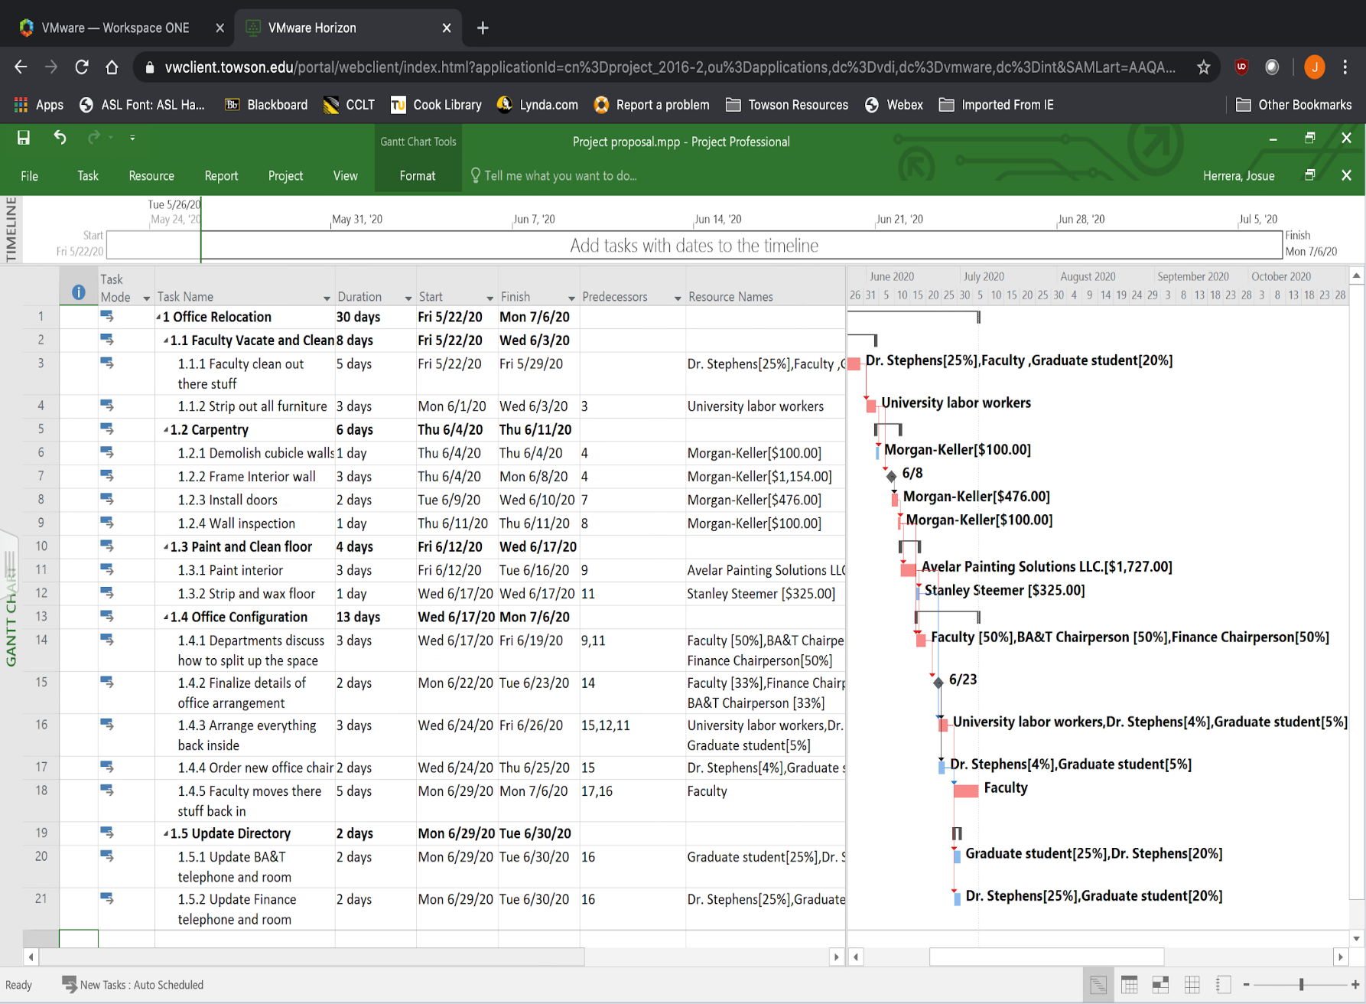**Gantt Chart**

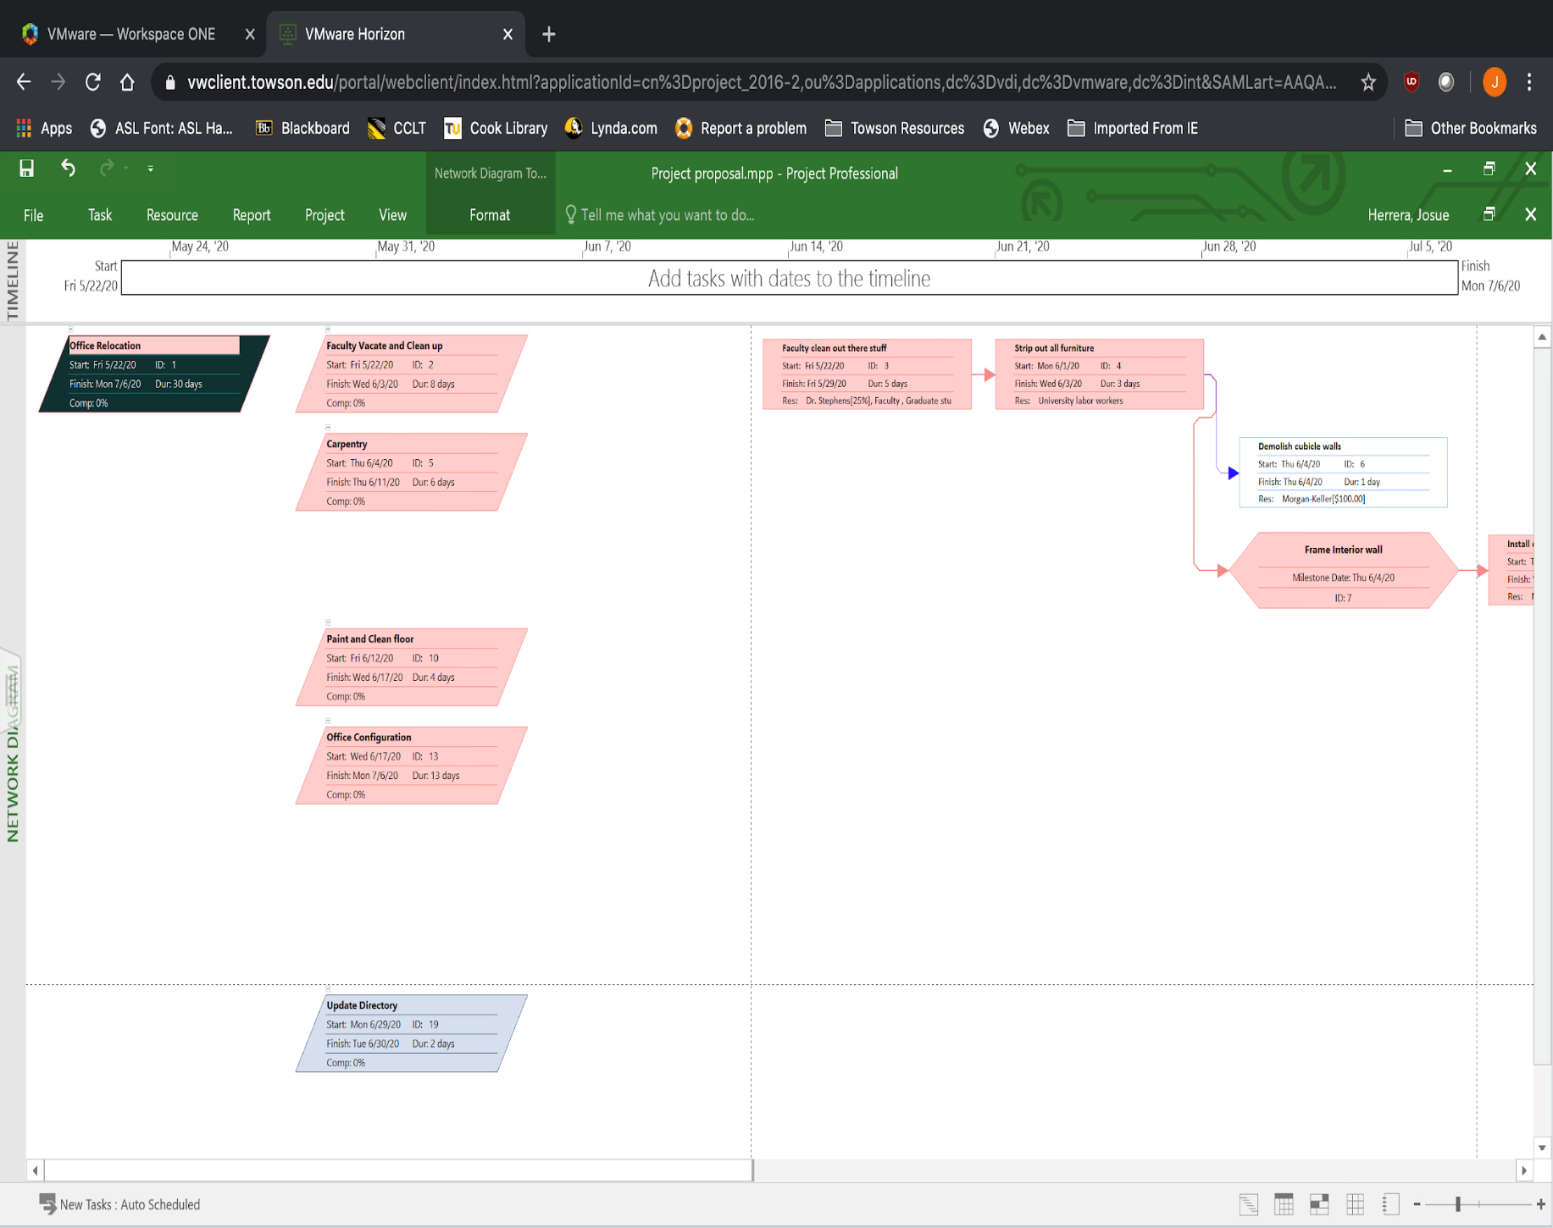**Network Diagram (1/3)**

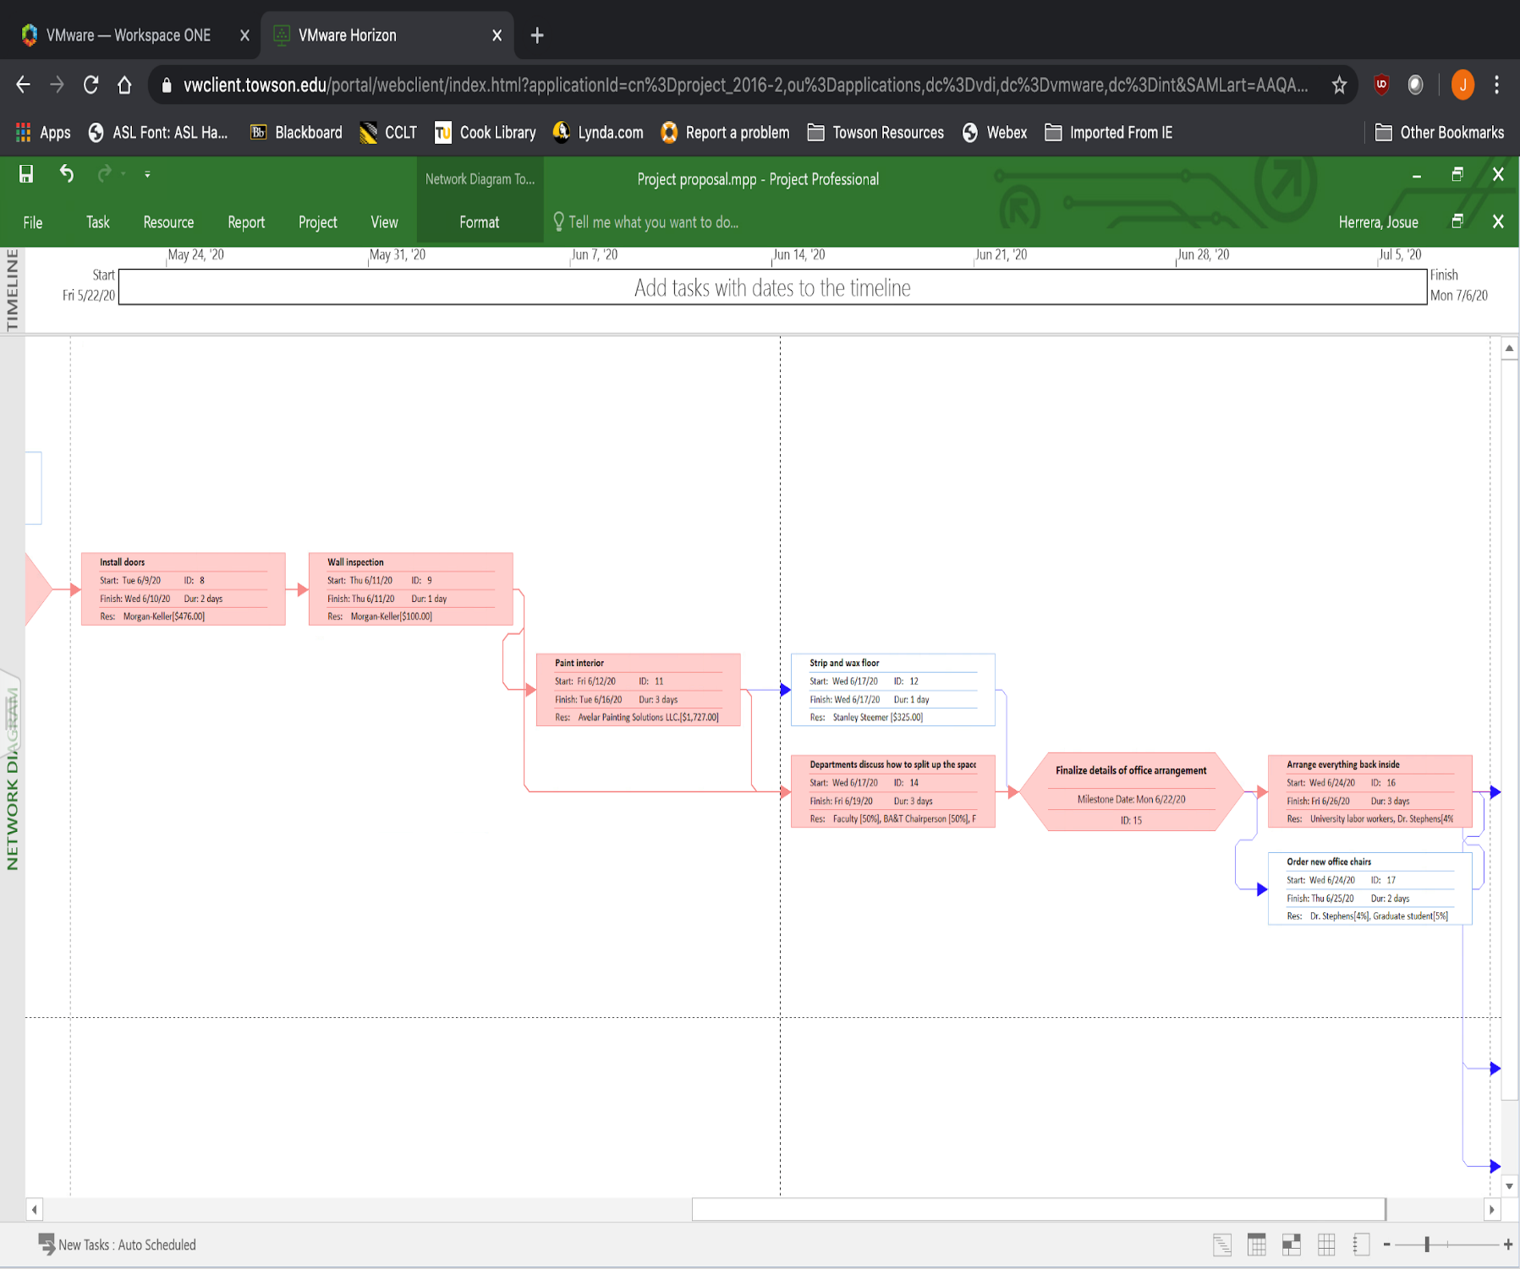**Network Diagram (2/3)**

PART 2

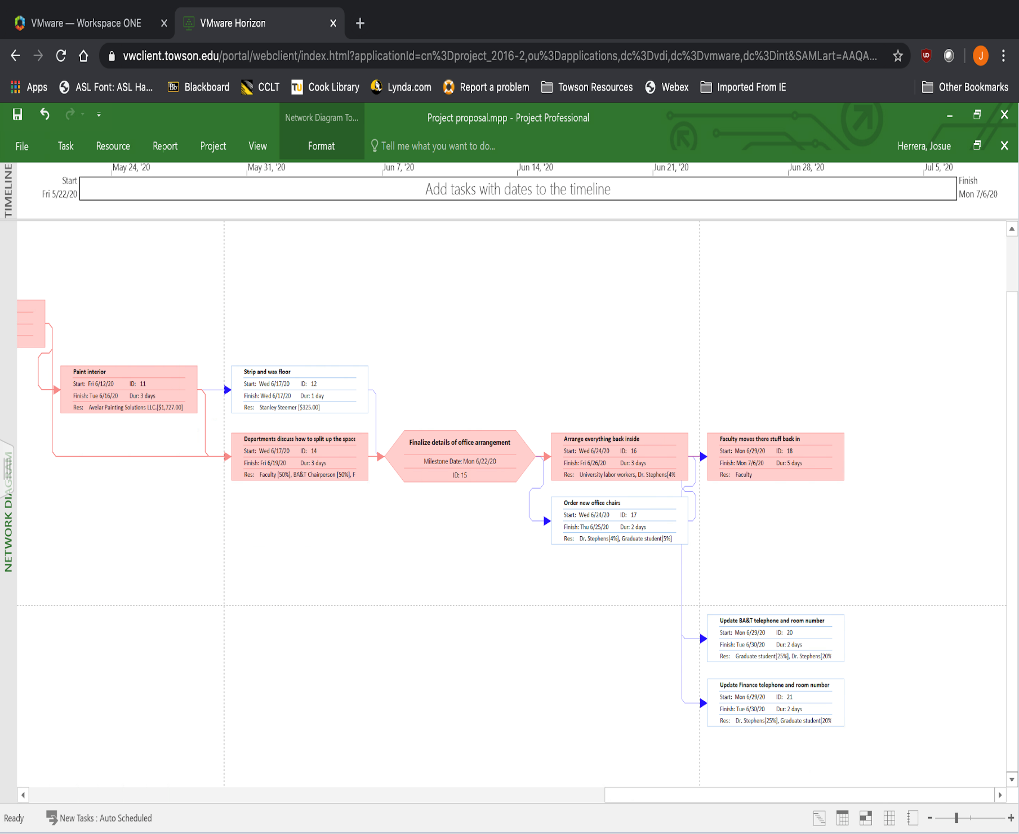**Network Diagram (3/3)**

PART 3

**Cash Flow Statement**

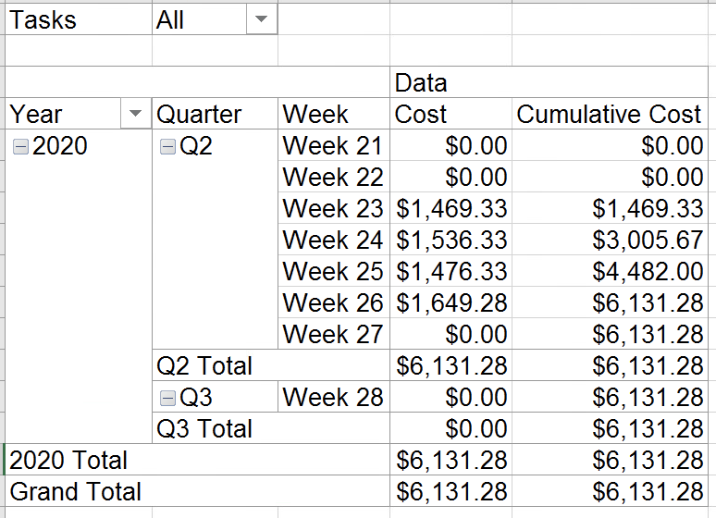

**Resource Costs**

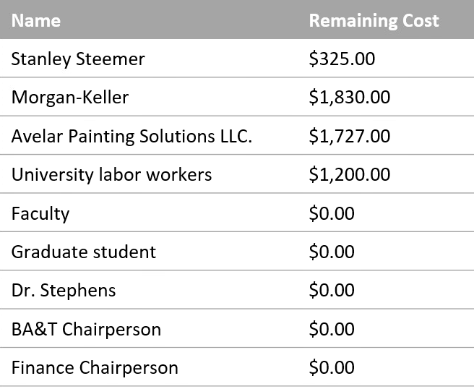

**Works Cited**

https://www.stanleysteemer.com/our-services/hardwood-cleaning

<https://www.morgankeller.com/>

<https://avelarpaintingsolutions.com/>

<https://www.homewyse.com/services/cost_to_frame_wall.html>

<https://www.homewyse.com/services/cost_to_frame_door_opening.html>

<https://www.homewyse.com/maintenance_costs/cost_to_strip_and_wax_floor.html>

<https://www.homewyse.com/services/cost_to_paint_rooms.html>

https://www.officedepot.com/a/products/219491/Realspace-Hurston-Bonded-Leather-High-Back/?cm_cat=593067